Experiment: 10
Aim: To load and display JSON data using the Fetch API and jQuery $.getJSON(), and dynamically render the retrieved data in an HTML table using HTML, CSS, and JavaScript.
Theory: SON (JavaScript Object Notation) is a lightweight format used to store and exchange structured data. In this experiment, JSON data is loaded from a data.json file and displayed dynamically in an HTML table using JavaScript.The Fetch API is used to request the JSON file asynchronously. fetch() returns a Promise, and response.json() parses the response into JavaScript data that can be processed and displayed. jQuery $.getJSON() provides another simple way to retrieve JSON data asynchronously. The retrieved data is then processed using JavaScript and inserted dynamically into the table using DOM manipulation.Thus, the experiment demonstrates how structured JSON data can be retrieved using both Fetch API and jQuery, and displayed dynamically without manually writing each table row.
Software/Tools Required: VSC, HTML, css, JavaScript
CODE:
Index.html:
<!DOCTYPE html>
<html lang="en">
<head>
<meta charset="UTF-8">
<meta name="viewport" content="width=device-width, initial-scale=1.0">
<title>JSON Data Viewer</title>

<link rel="stylesheet" href="style.css">

<script src="https://code.jquery.com/jquery-3.7.1.min.js"></script>
</head>

<body>

<div class="container">
<h1>Student JSON Data</h1>

<div class="buttons">
<button id="fetchBtn">Load using Fetch()</button>
<button id="jqueryBtn">Load using $.getJSON()</button>
</div>

<p id="message"></p>

<table>
<thead>
<tr>
<th>ID</th>
<th>Name</th>
<th>Course</th>
<th>Marks</th>
</tr>
</thead>

<tbody id="tableBody"></tbody>
</table>
</div>

<script src="script.js"></script>
</body>
</html>
script.js:
function displayData(data) {

let tableBody = document.getElementById("tableBody");

tableBody.innerHTML = "";

data.forEach(function(student) {

let row = `
<tr>
<td>${student.id}</td>
<td>${student.name}</td>
<td>${student.course}</td>
<td>${student.marks}</td>
</tr>
`;

tableBody.innerHTML += row;
});
}

// Fetch API
document.getElementById("fetchBtn").addEventListener("click", function() {

document.getElementById("message").textContent =
"Loading using Fetch()...";

fetch("data.json")
.then(function(response) {

if (!response.ok) {
throw new Error("JSON file could not be loaded");
}

return response.json();
})
.then(function(data) {

displayData(data);

document.getElementById("message").textContent =
"Data loaded successfully using Fetch()";
})
.catch(function(error) {

document.getElementById("message").textContent =
"Error: " + error.message;
});
});

// jQuery $.getJSON()
document.getElementById("jqueryBtn").addEventListener("click", function() {

document.getElementById("message").textContent =
"Loading using $.getJSON()...";

$.getJSON("data.json", function(data) {

displayData(data);

document.getElementById("message").textContent =
"Data loaded successfully using $.getJSON()";

}).fail(function(jqXHR, textStatus, errorThrown) {

document.getElementById("message").textContent =
"Error: " + textStatus;
});
});
style.css:
* {
box-sizing: border-box;
margin: 0;
padding: 0;
}

body {
font-family: Arial, sans-serif;
background: #f3f4f6;
min-height: 100vh;

display: flex;
justify-content: center;
align-items: center;
}

.container {
width: 850px;
background: white;
padding: 30px;
border-radius: 12px;
box-shadow: 0 5px 20px rgba(0, 0, 0, 0.12);
}

h1 {
text-align: center;
margin-bottom: 25px;
}

.buttons {
display: flex;
justify-content: center;
gap: 15px;
margin-bottom: 20px;
}

button {
padding: 11px 20px;
border: none;
border-radius: 6px;
background: #2563eb;
color: white;
font-size: 15px;
cursor: pointer;
}

button:hover {
background: #1d4ed8;
}

#message {
text-align: center;
margin-bottom: 15px;
color: #555;
}

table {
width: 100%;
border-collapse: collapse;
}

th,
td {
padding: 12px;
border: 1px solid #ddd;
text-align: center;
}

th {
background: #2563eb;
color: white;
}

tr:nth-child(even) {
background: #f8fafc;
}

tr:hover {
background: #eef2ff;
}

Output:
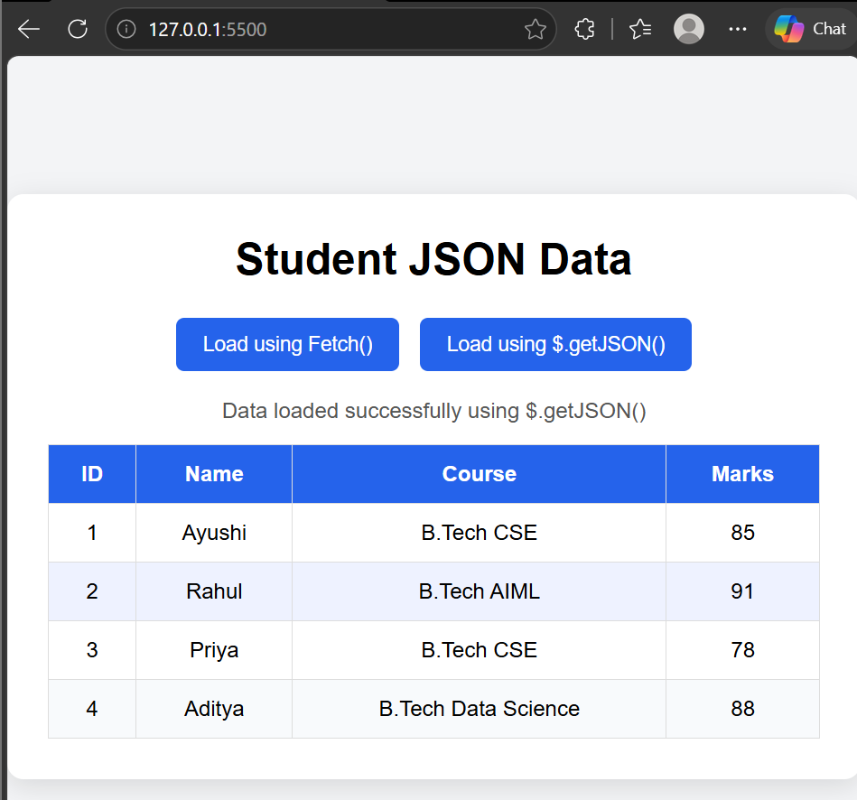

Result: The JSON data was successfully loaded using both fetch() and jQuery $.getJSON(). The retrieved student information was dynamically rendered in an HTML table containing ID, Name, Course, and Marks.
Hence, JSON data was successfully fetched and displayed dynamically using JavaScript and jQuery.

